**21.Hospital Management system**

**USE CASE DIAGRAM:**

[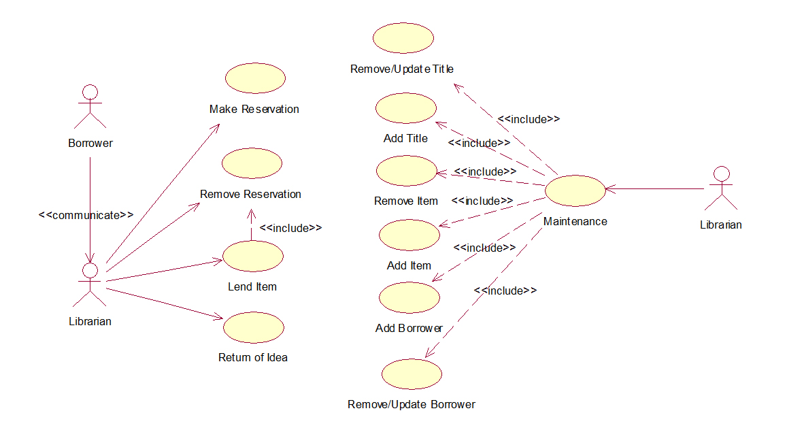](https://www.startertutorials.com/uml/wp-content/uploads/2013/10/LMS-Use-Case-Diagram.jpg)

**USE CASE DIAGRAM:**

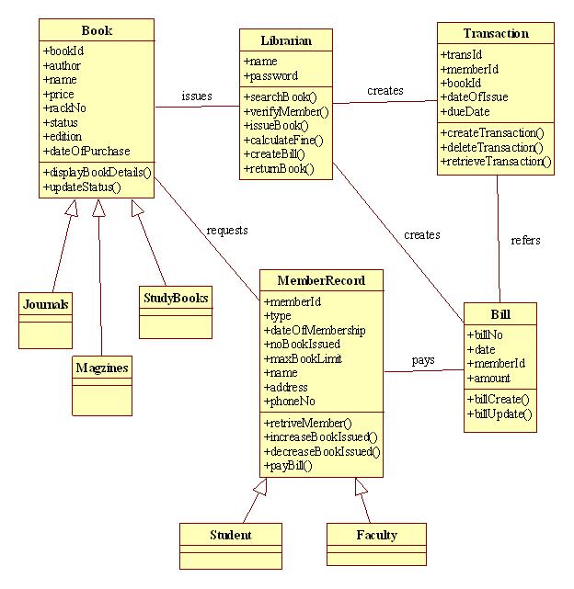

**ACTIVITY DIAGRAM:**

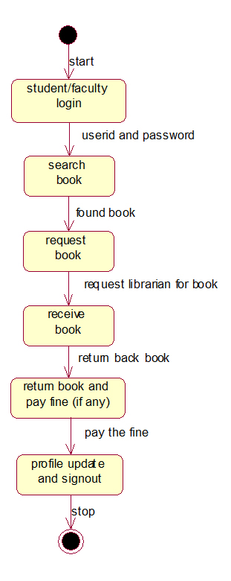

**SEQUENCE DIAGRAM:**

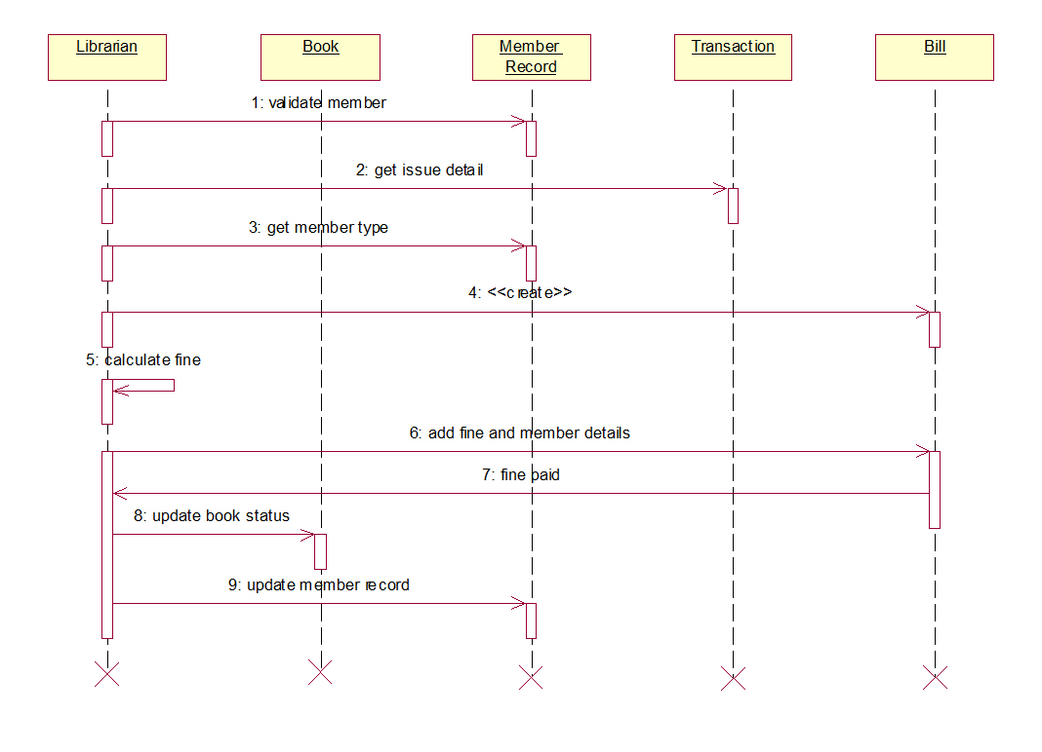

**COLLABORATION DIAGRAM:**

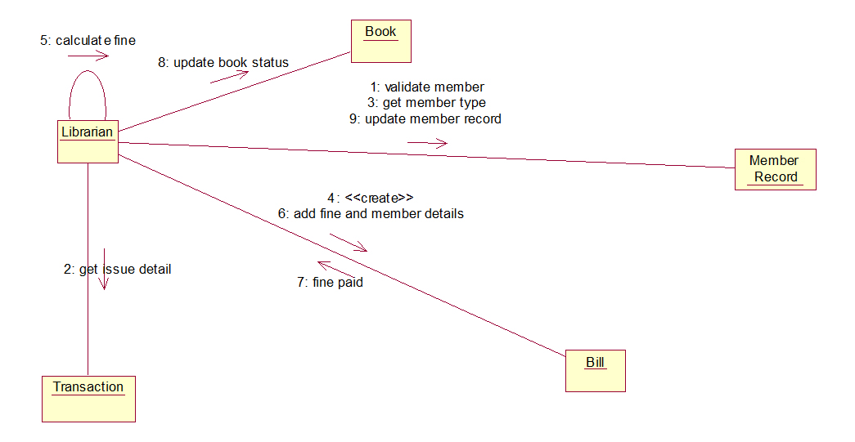

**DEPLOYMENT DIAGRAM**

